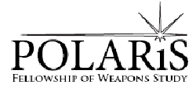

Media Release Form

I grant Polaris Fellowship of Weapons Study permission to use my photographic images, video or audio capture of my participation in their events or classes on their website, social networking sites, advertising, and for educational purposes. Images will remain unassociated with my name unless I chose to tag them on the Internet or I inform Polaris that they may use my name in association with my image for the purposes of networking. If I would like an image of me removed, I have the right to request it be taken down, Polaris will review the image and reserves the right to determine whether or not it will be removed. It is agreed that the use any of the aforementioned digitally captured content shall not be used other then by and for Polaris Fellowship of Weapons Study. I understand that I will not be compensated for the use of my captured image, and that all media remains the property of Polaris Fellowship of Weapons Study.

I have carefully read the terms and conditions above, understand them fully, and agree to this release and waiver.

___ Polaris may tag pictures and videos of me with my name/contact information.

Name:________________________________________________
Signature:____________________________________________
Date:_________________________________________________
Parent Signature if under 18: ___________________________________________

